|  |  |
| --- | --- |
| **Nikon D7500 (Body Only)** Máy ảnh Nikon D7500 (Body Only) | Chính hãng VIC  Nikon D7500 Nhập khẩu.8 Nikon D7500 Nhập khẩu.3 Nikon D7500 Nhập khẩu.7 Nikon D7500 Nhập khẩu.11 | **Featured information:**  Sensor: APS-C  ISO range: 100 - 51200 (expandable 50 - 1640000)  Resolution: 20.9MP  Wireless connection: WiFi, bluetooth  **Price: $980**  **Specifications:**  Sensor Format  APS-C (1.5x Crop Factor)  Resolution  21.51 Megapixels  Size photo  5568 x 3712  Image Proportions  3:2, 16:9  Sensor Type  CMOS  Image Format  JPEG, Raw  Anti-Vibration  Digital |

**Overview:**

Quite similar to many Nikon DSLR cameras, the D7500 is also designed with a monocoque carbon fiber shell with good bearing capacity, working effectively in many different environmental conditions, without making the camera feel uncomfortable. heavy to hold.

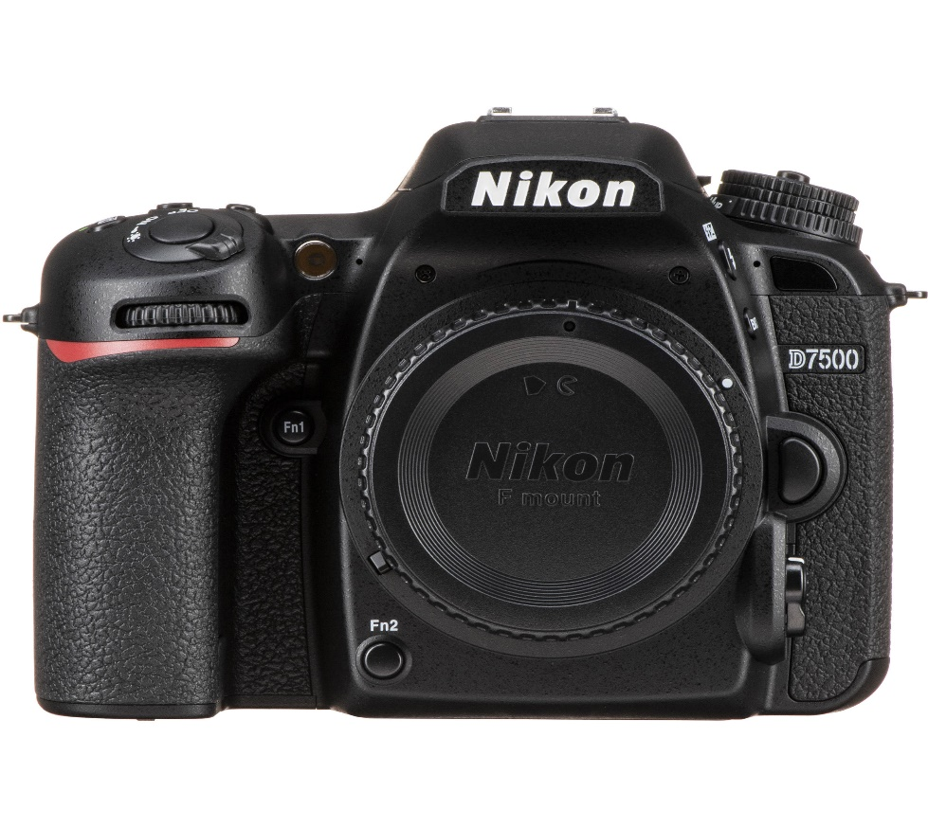

The D7500 has a 3.2-inch tilting touch screen, 922,000 pixels, 640 x 480 pixel resolution, allowing users to flexibly adjust the shooting angle depending on the height.

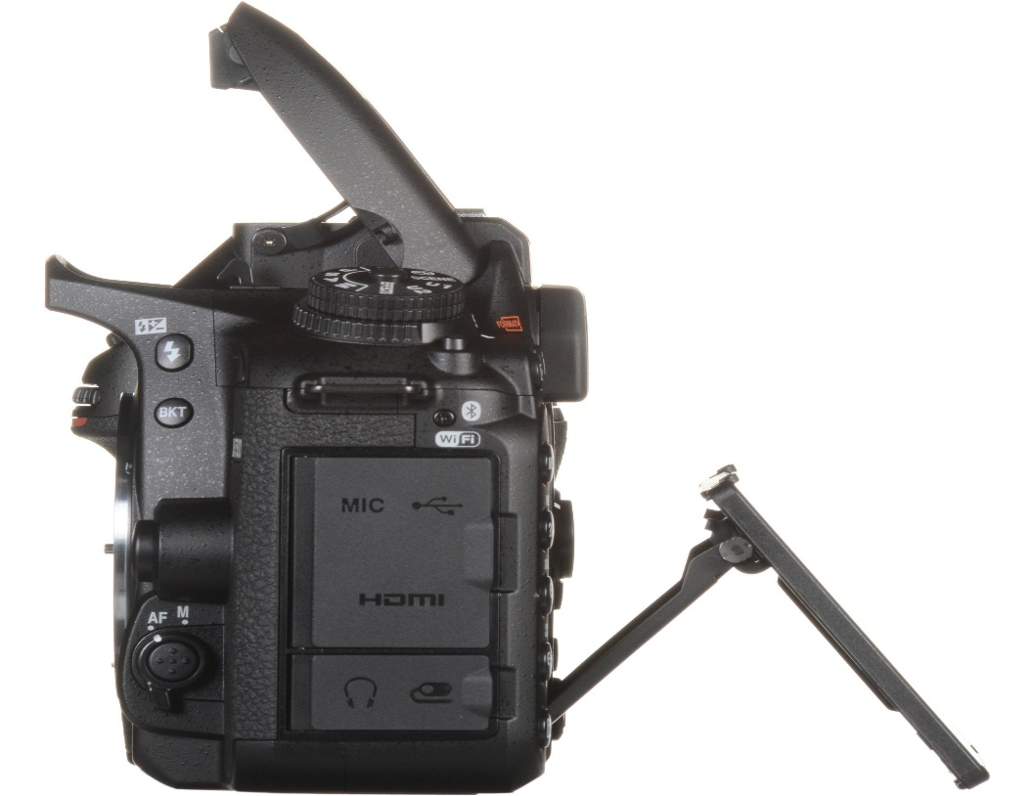

The optical viewfinder design covers the entire frame, plus 0.94x magnification to help display images clearly and realistically regardless of lighting conditions.

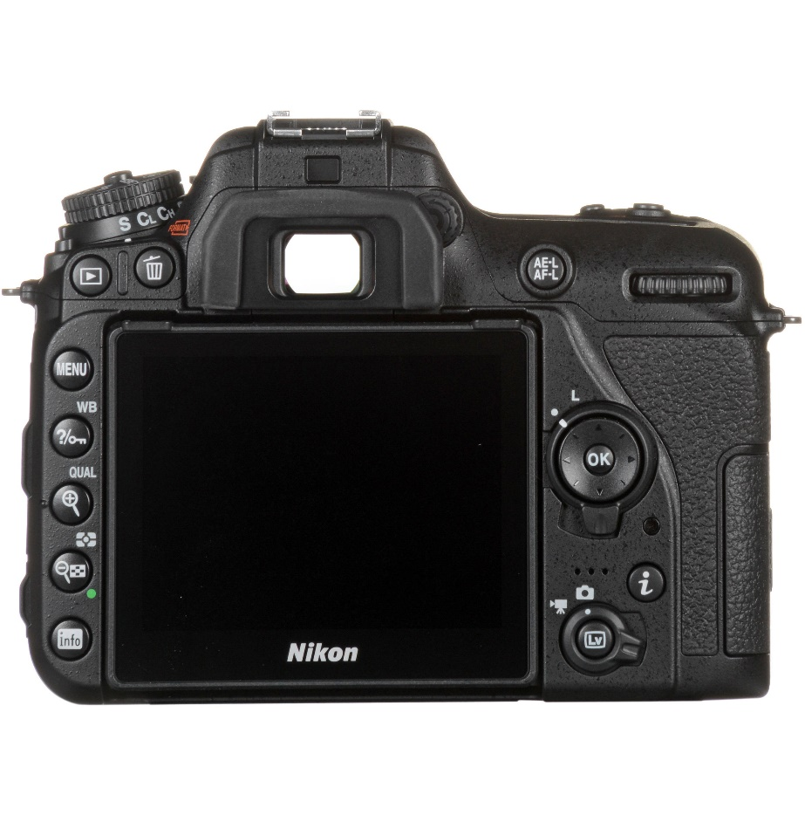

Similar to the D500, the Nikon D7500 also uses the same 20.9MP DX CMOS sensor and EXPEED 5 image processor for sensitive processing and realistic images. The camera's ISO range is from 100 - 51200 and can be expanded to 50 - 1640000 to help handle light best in many different conditions.

Continuous shooting speed